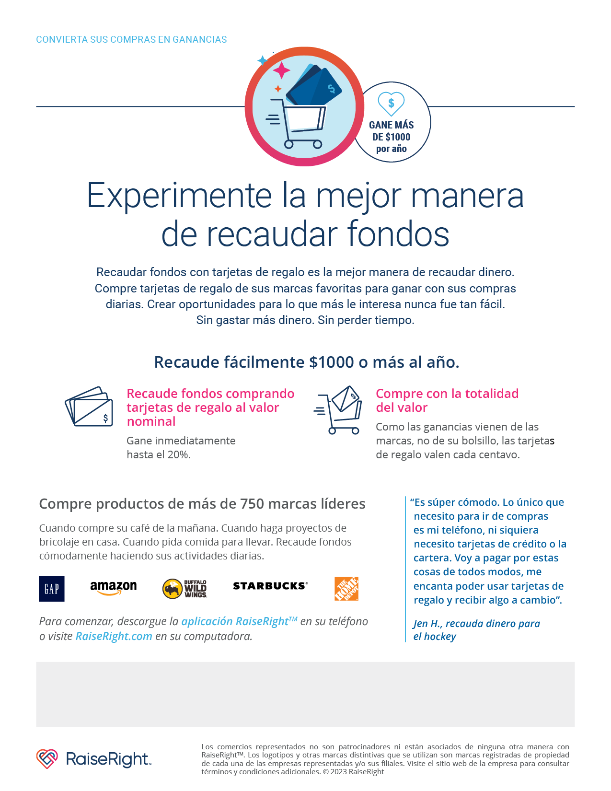

*To enroll in the PVCA RAISERIGHT program scan the QR code with your phone or use enrollment code* **72E9D189834L**

*For questions contact: Jessica Gonzalez at* [*PVCSTRIP965@GMAIL.COM*](mailto:PVCSTRIP965@GMAIL.COM)